Lab 2 — AWS Security Posture Assessment with Prowler

Objective
Connect an AWS account to Prowler, run a cloud security scan, and review the findings reported by the dashboard.

Tools
- Prowler — cloud security posture assessment
- AWS account — the account being assessed

Procedure

1. Open Prowler
Log in to Prowler and start the workflow to add a cloud provider.
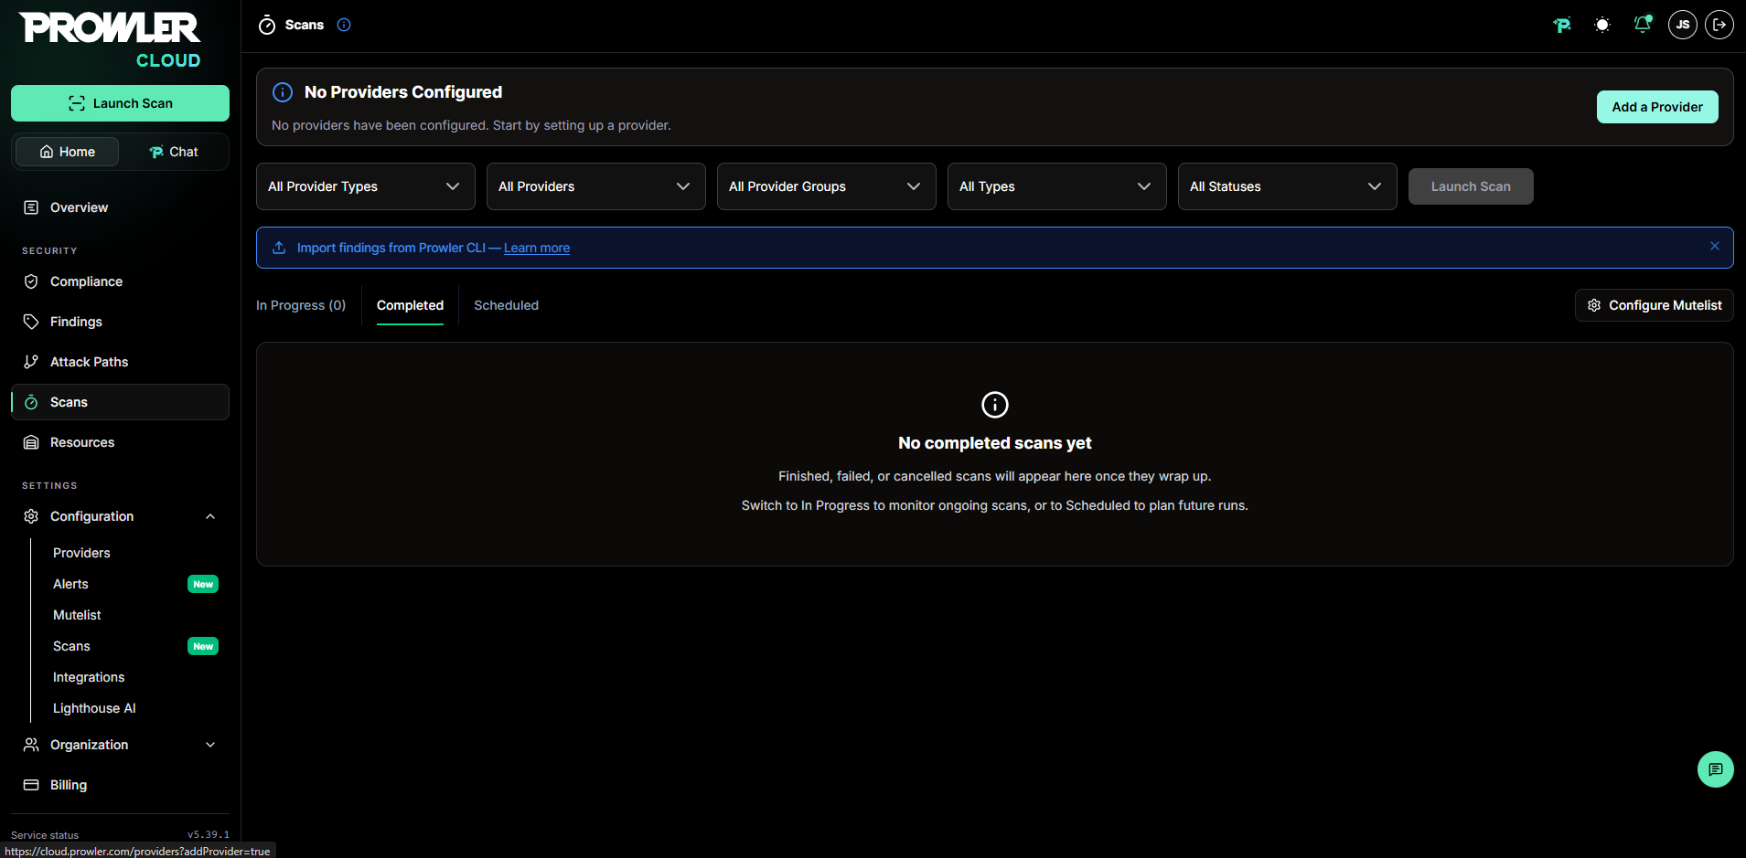
1. Open Prowler

2. Select AWS
Choose Amazon Web Services (AWS) as the provider.
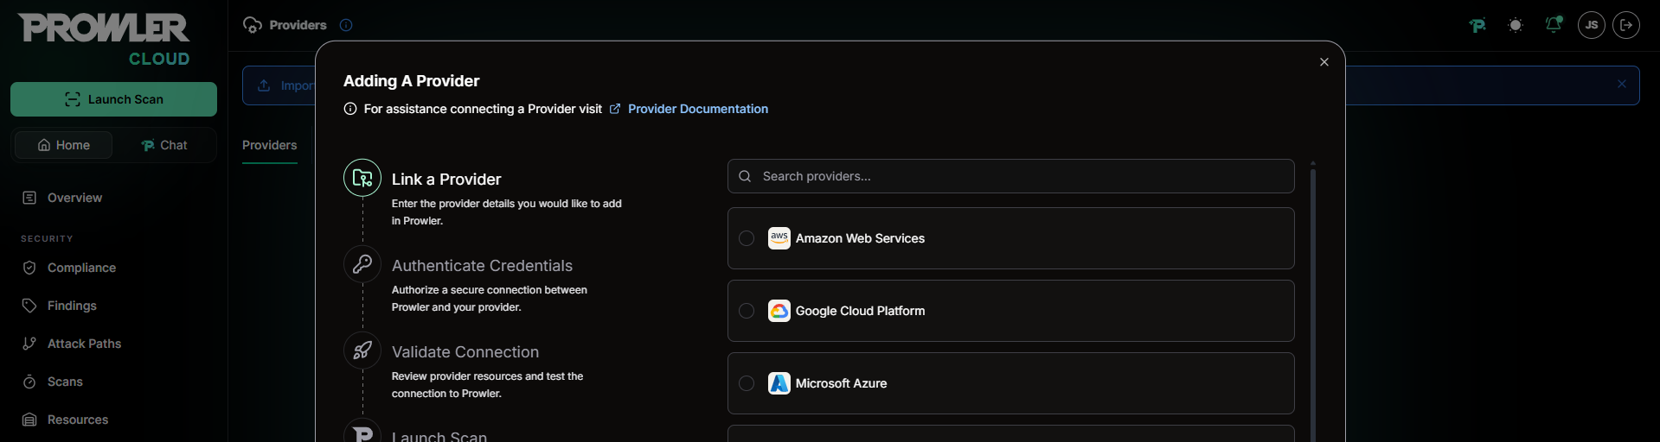
2. Select AWS

3. Add a single AWS account
Choose the option to add a single AWS account.
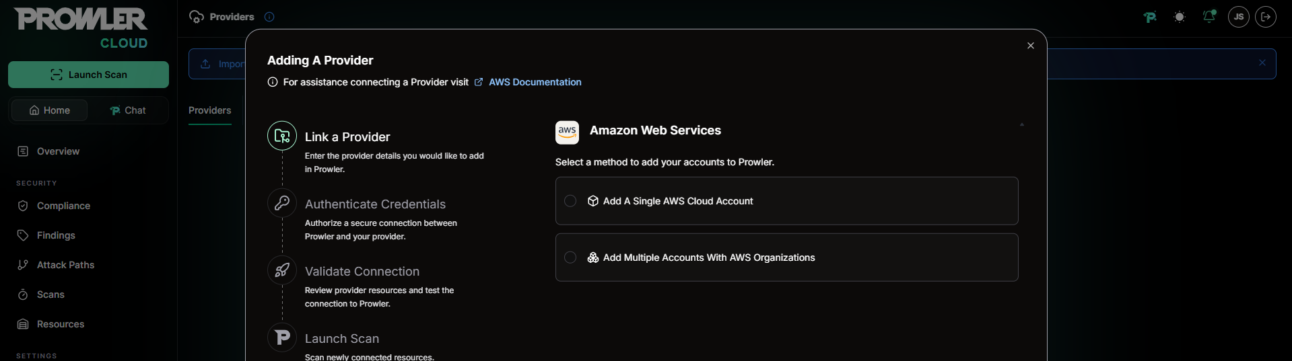
3. Add a single AWS account

4. Enter the AWS account details
Enter the AWS account ID for the account you intend to assess.
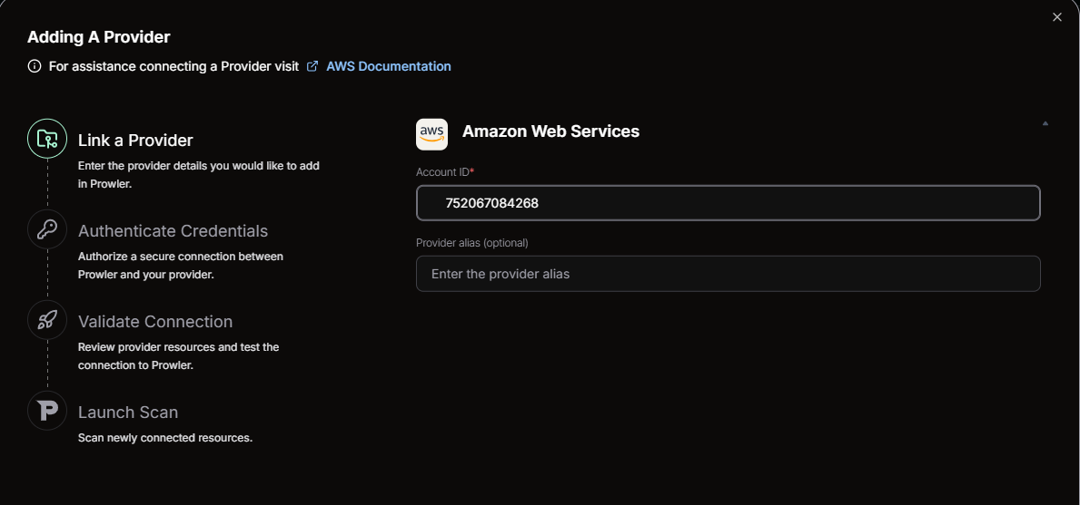
4. Enter the AWS account details

5. Choose credential-based authentication
Select Connect via Credentials to configure authentication.
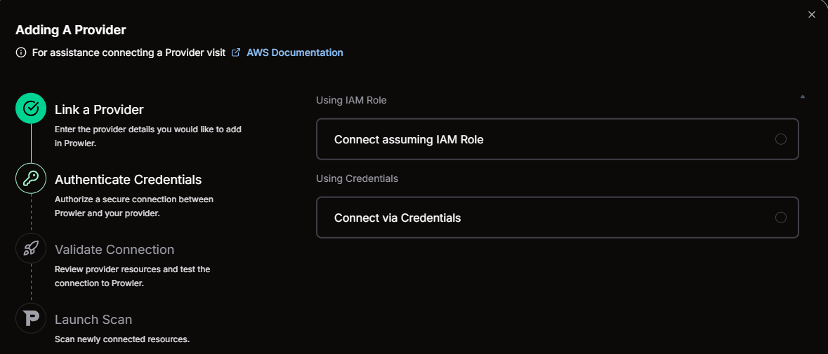
5. Choose credential-based authentication

6. Configure AWS credentials
Provide the required AWS credentials in the Prowler connection form, then continue to authentication.
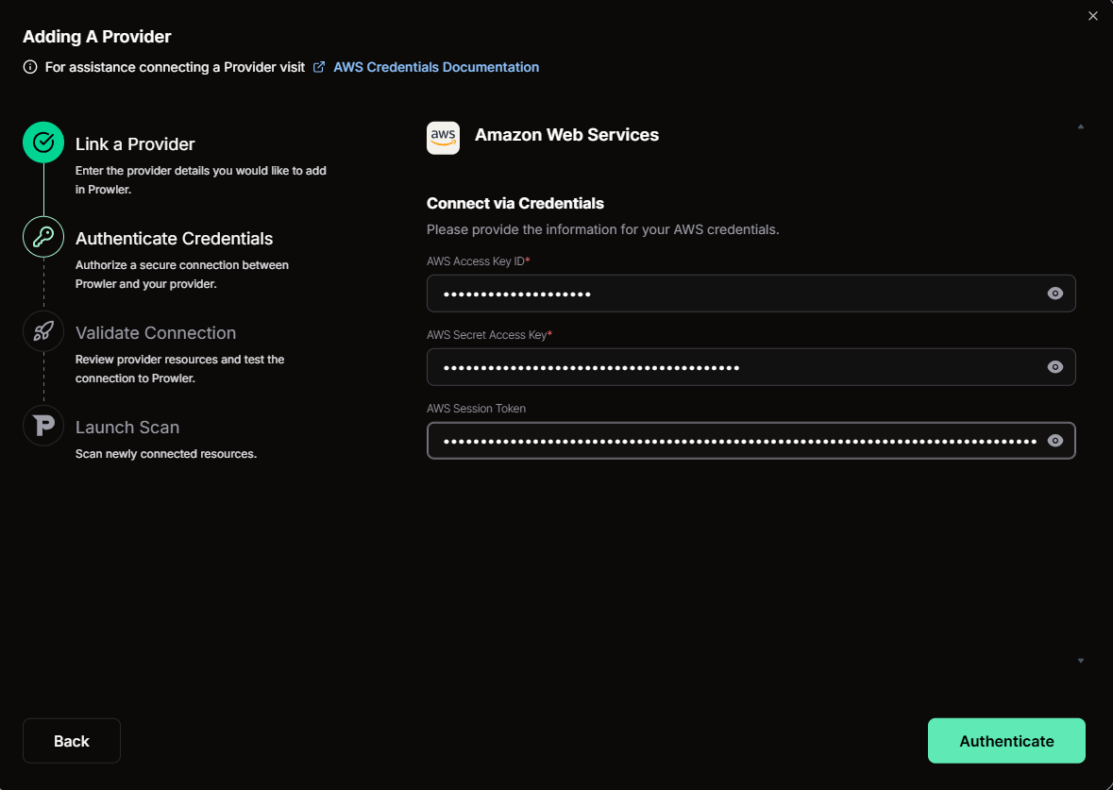
6. Configure AWS credentials

7. Validate the connection
Run the connection check and confirm that Prowler can access the AWS account.
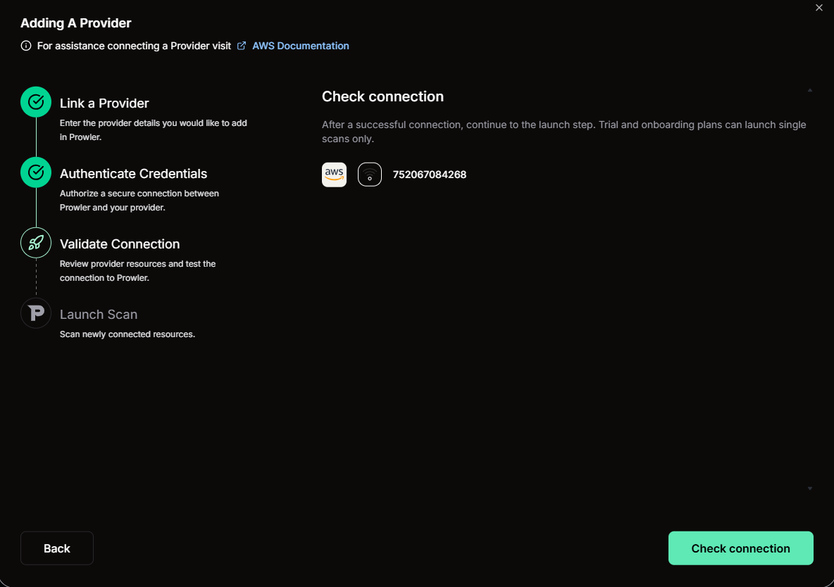
7. Validate the connection

8. Launch the scan
Start the scan for the connected AWS account.
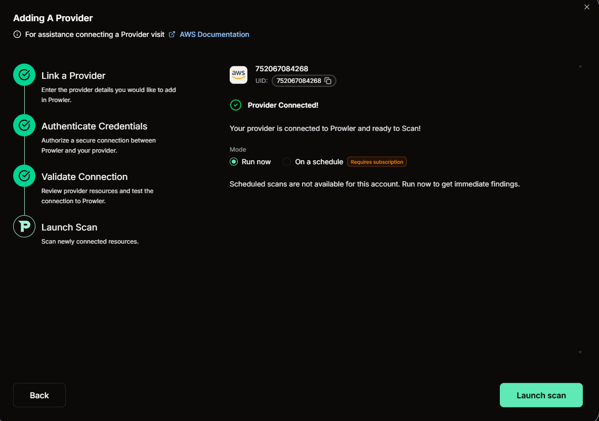
8. Launch the scan

9. Monitor scan progress
Use the Prowler dashboard to check the scan status and wait for the scan to complete.
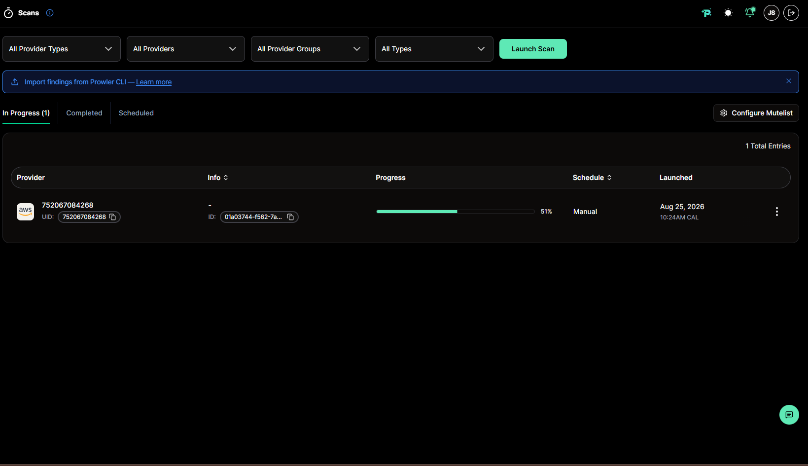
9. Monitor scan progress

10. Review the findings
Open the findings report and review detected security issues. Prioritize findings based on severity, affected resources, and remediation guidance.
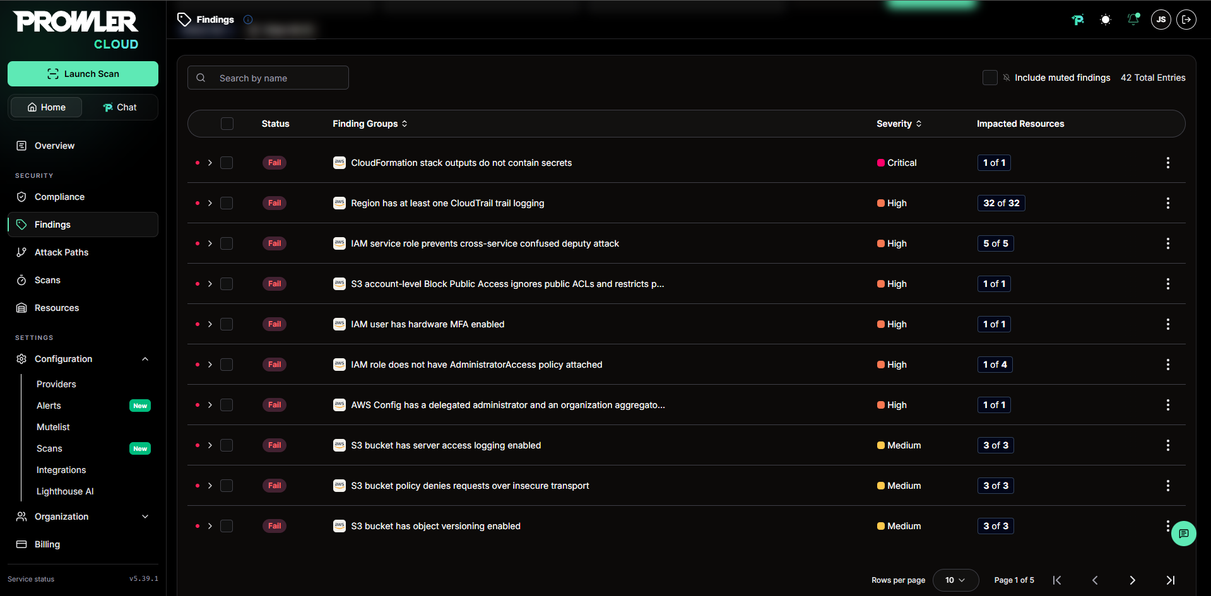
10. Review the findings

Security Note
Never commit access keys, secret keys, session tokens, or other credentials to GitHub. Use temporary credentials or an IAM role where possible, grant only required permissions, and rotate any credential that may have been exposed.

Result
An AWS account was connected to Prowler, a security scan was launched, and the resulting findings were displayed in the dashboard.

Notes
- Findings depend on the AWS account configuration and the permissions available to the scanner.
- Treat the report as an assessment snapshot; rerun the scan after remediation to verify changes.

